**Rá House**

MVP of TestFit and Layout

August 11, 2021

# Overview

The next series of tools are concentrating all developments done so far and had been tested with their specific categories with a Revit Template File on this document would set requirements of functions and the runabouts of all of them.

So there are 11 Functions that are holding all the processes

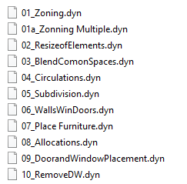

# A template File and a Excel File with Setbacks

Additional to that youll need to have installed the library functions on the C:/BIM/RA Folder on computer to Run Properly

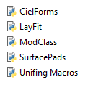

All tools would run on Dynamo Player by selecting the folder where they are and running it.

# 01_Zonning

1. **Requirements:**
   1. Use of the template
   2. The four lines of the Site Location to Work Around being in order and configured.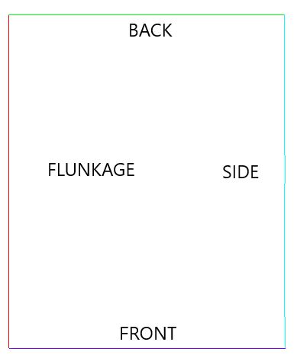
   3. Had on the Template the family of MACROS
2. **Function** its to create zoning possibilities with the set arounds.
3. **Result-** Set of zoning elements to be review, selection of setbacks its required.

# 

# 01a_Zonning Multiple

1. **Requirements:**
   1. Use of the template
   2. The four lines of the Site Location to Work Around being in order and configured.
   3. Had on the Template the family of MACROS
2. **Function** its to create multiple possibilities for allocation of zoning
3. **Result-** 12 sets of possibilities of zoning by the selection of setbacks

# 

# 02_ResizeofElements

1. **Requirements:**
   1. Use of the template / with proper allocation of Macros and proper size.

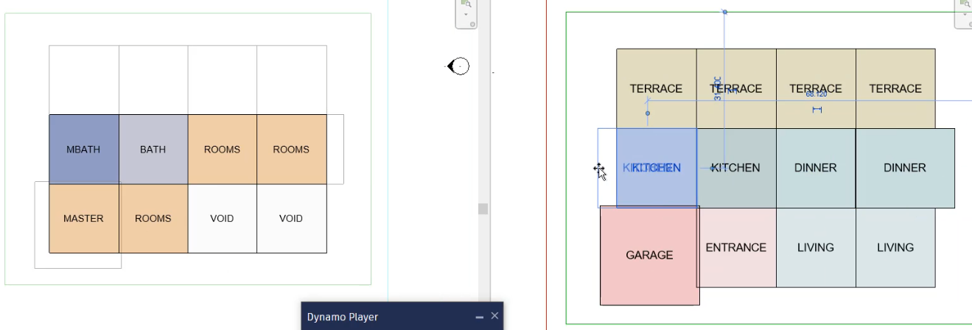

1. **Function** Since its necessary complete 0.000000 precision for the space to work around it fixes any gaps between MACROS
2. **Result-** perfectly Aligned Grid elements

# 

# 

# 

# 

# 

# 03_BlendComonSpaces

1. **Requirements:**
   1. A file of Macros with same naming convention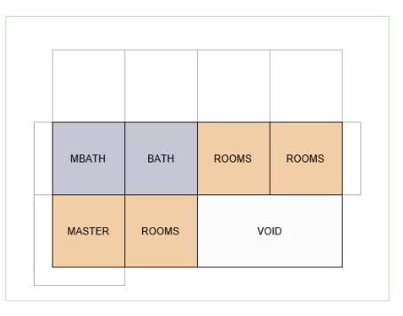
2. **Function** to add adjacency MACROS created
3. **Result-** Simplify Functions

# 

# 

# 

# 

# 

# 04_Circulations

1. **Requirements:**
   1. Had a logical set of elements to be circulated.

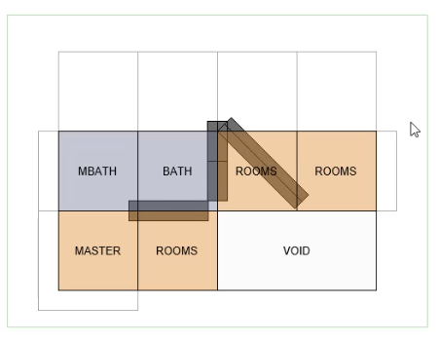

1. **Function** it create on both plans a Circulation Family that can be modified to best fit requirements of multiple spaces, and set the decision taking process.
2. **Result-** Placement of Circulant a family for separating spaces for circulation

# 05_Subdivisions

1. **Requirements:**
   1. A Zoning File with Circulant placed properly on existing space
   2. 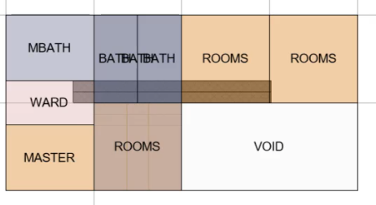
2. **Function** It separates Zonnings by the Circulation orientation so that longer spaces can be extended to multiple spaces.
3. **Result-** Subdivision of elements
4. NOTE(SO FAR USE ONLY FOR BATH AND ENTRANCE)

# 06_WallsWinDoors

1. **Requirements:**
   1. Zoning, and Circulations.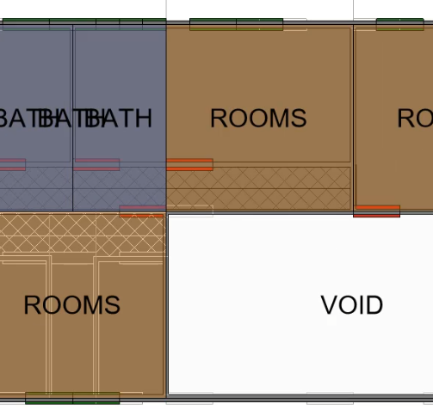
2. **Function** it would create Floors, Walls (Exterior and Interior and would set randomly logic a DW family that can be modify as best fit to give the project allocation of accessibility and doors.).
3. **Result-** A first version of Layout

# 

# 

# 

# 07_Place Furniture

1. **Requirements:**
   1. Zoning,Circulations, DW families for Doors and Windows, and Walls 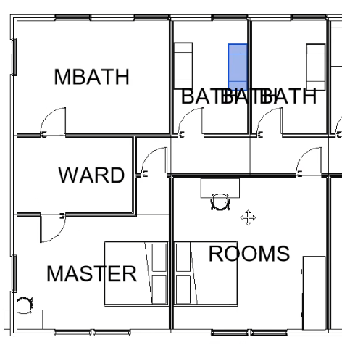
2. **Function** it would create General Furniture spaces depending on the config of spaces doors and windows
3. **Result-** A layout of posible elements on space
4. NOTE(It has configured Rooms, Baths, Toilets, and WARDS)

# 08_Allocations

1. **Requirements:**
   1. Zoning,Circulations, DW families for Doors and Windows, and Walls 
2. **Function** it would create Furniture on a particular space that where deleted or reconfigured
3. **Result-** A layout of posible elements on space
4. NOTE(It has configured Rooms, Baths, Toilets, and WARDS)

# 09_DoorsandWindowsPlacement

1. **Requirements:**
   1. Zoning,Circulations, DW families for Doors and Windows, and Walls 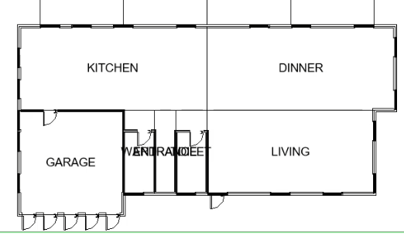
2. **Function** it would place the families and measurements describe inside the DW_SET family
3. **Result-** A generic overview of the plan layout

# 

# 

# 

# 

# 10_RemoveDW

1. **Requirements:**
   1. DW families Set
2. **Function** it would delete all DW families that where used in the proyect
3. **Result-** Cleans out the layout